

  
***Academics to Action:***

***Advancing Road Safety for Children and Teens***

**Flaura Winston, MD, PhD**

*Professor of Pediatrics, University of Pennsylvania*

*Scientific Director   
Center for Injury Research and Prevention*

*Children’s Hospital of Philadelphia*

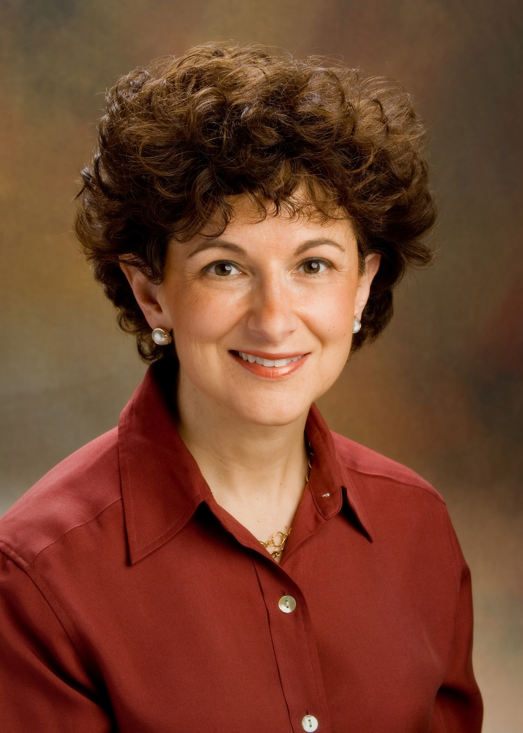

**Thursday, November 15** at 3:00 p.m.

*College of Public Health Building Room S-030*

Dr. Winston is a board-certified pediatrician, biomechanical engineer, and public health researcher. Her interdisciplinary work focuses on traffic injury, specifically teen driver safety, child occupant protection and promotion of recovery after child injury.

In addition to serving as the Scientific Director of the Center for Injury Research and Prevention at the Children’s Hospital of Philadelphia, she is the Director of the National Science Foundation Industry/University Cooperative Research Center, the Center for Child Injury Prevention Studies and the National Science Foundation Research Experience for Undergraduates.

*\*NOTE: Individuals with disabilities are encouraged to attend all University of Iowa-sponsored events. If you are a person with a disability who requires an accommodation in order to participate in this program, please contact:   
kathy-holeton@uiowa.edu.*

 Macintosh HD:Users:cpfry:Downloads:IPRClogo-approved July, 2012.eps.eps 

